Project Report
User Experience Design - Principles & Methods
Alternative C – Travel Buddy Application

Module: User Experience Design - Principles & Methods
Study Program: Master of UX & Service Design
Professor: Prof. Dr. Jurgen Faust

Student: Van Nguyen Phuc Tuong
Email: Van.NguyenPhucTuong@stud.mobile-university.de
Matriculation Number: 2031444

1. Introduction 2
1.1 What is Travel Buddy? 2
1.2 The problem it addresses 2
2. Process Framing & Planning 3
2.1 Chosen double diamond process 3
2.2 Strategic Objective 3
3. Stakeholder Ecosystem 4
4. User personas 5
5. Research Design Methodology 6
5.1 Competitive SWOT Analysis 6
5.2 Key Insights & Affinity Clustering 7
6. Feature Strategy 8
6.1 Discovery 9
6.2 Connect 9
6.3 Plan 10
6.4 Collaborative 10
6.5 Journal and Memory 11
7. System flow and Information Architecture 11
7.1 Card sorting 11
7.2 User flow 12
8. Prototype 12
9. Validation 14
10. Portfolio & Strategic Reflection 15
10.1 UX Strategy Summary 15
10.2 Value Logic 15
10.3 Critical Reflection 16
References 16
Appendix 17

1. Introduction

1.1 What is Travel Buddy?
Travel Buddy is a mobile platform designed to help people, especially travelers, discover places, connect with locals, plan, and share travel experiences. Unlike existing famous platforms that only serve one part of the travel journey, Travel Buddy combines three pillars Discover, Connect, and Plan & Share into one platform with a seamless experience.

This submission documents the end-to-end UX strategy for Travel Buddy, following the Double Diamond process model. It moves from research and stakeholder analysis through feature definition and information architecture to prototyping and usability testing and concludes with a strategic reflection on the full UX value logic.

1.2 The problem it addresses
Travelers who need a way to plan their trip, connect with locals, and save memories, but are struggling with too many tools and apps that serve specific purposes, making it hard to enjoy a full trip and capture good memories.
The problem is relevant for three reasons. First, trust in online travel information is fragile: fake reviewer identities and ulterior motives raise consumer distrust of online reviews (Ahmad & Sun, 2018). Second, the market splits travel functions across separate app categories, namely mobility, navigation, interaction and experience, and social media (Birenboim et al., 2023), so a traveller who wants to move, discover and share needs several apps. Third, demand is shifting towards authentic, local experiences, particularly among Gen Z and millennials (Gilbert-Jones, 2024). Travel Buddy addresses the point where these three meet: trusted local content, local connection, and planning and memory in one place.

2. Process Framing & Planning

2.1 Chosen double diamond process
The Double Diamond process is a comprehensive, visual model for innovation. It is used to address complex social, economic, and environmental challenges. The model divides the process into two 'diamonds': one representing divergent thinking—expanding understanding of an issue—and the other convergent thinking—taking focused action. There are four defined stages within this framework.
Step | Description
Discovery | The initial phase focuses on understanding the needs and behaviors of those affected by the issue. The aim is to gain genuine user comprehension, avoiding assumptions about the actual problem.
Define | Evaluating and prioritizing insights helps redefine the challenge.
Develop | This stage centers on co-designing solutions with a diverse group of contributors. The objective is to encourage a range of solutions to the clearly defined problem.
Delivery | This stage involves testing various solutions within small user groups. Solutions that address identified needs are adopted, while ineffective ones are refined or replaced.
Table 1: Double diamond process

The Double Diamond methodology was selected because it prioritizes user needs, fostering a deep understanding of how individuals engage with products and services. The approach effectively communicates insights to team members and stakeholders, promoting collaborative, user-centered development. Furthermore, its iterative nature supports continual refinement and confidence-building throughout the process.
Table 1b maps the four phases to the activities, methods and deliverables of this project. Each phase has a defined purpose: Discovery widens the view through research, Define narrows it to a prioritised set of needs and features, Develop widens it again through structure and design exploration, and Delivery narrows it through testing and reflection. The methods were chosen for what each phase needs to decide, as the last column of the table explains. Where a method has been designed but not yet run, or where metrics were not captured, the table states this, and Section 10.3 returns to these limits.
Phase | Activities | Methods | Deliverables | Why this method here
Discovery | Set research hypotheses; survey and interview travellers; analyse competitors and stakeholders | Online survey (n = 13); semi-structured interviews (number completed: to be confirmed); competitor SWOT; stakeholder mapping | Hypothesis list; survey data; SWOT tables (Tables 3 and 4); stakeholder map | The survey gives breadth to test the hypotheses, the interviews explain the reasons behind the behaviour, and the SWOT locates the market gap before any solution is chosen.
Define | Synthesise findings; define user types; select features | Affinity clustering; personas; feature prioritisation (MoSCoW, to be added) | Five insight clusters; personas; feature tables (Tables 5 to 9) | Converges scattered findings into a few decisions, so the team builds for evidenced needs instead of for all ideas at once.
Develop | Structure the product; map the journey; design screens | Open card sort (designed, not yet run with participants); sitemap; user flow; wireframes, then high-fidelity prototype | Card sort board; IA sitemap; user flow; clickable prototype | The card sort is chosen to reveal users' mental models before navigation is fixed; moving from wireframe to high-fidelity keeps design decisions cheap to change early.
Delivery | Test the prototype with users; record issues; derive improvements | Moderated think-aloud test (n = 3); severity rating; SUS and task-completion metrics not yet captured | Testing insights (Table 11); recommendations; critical reflection | Think-aloud shows why users struggle, not only where, and small samples suit an early prototype; metrics are the planned next step.
Table 1b: Travel Buddy project mapped to the four Double Diamond phases

2.2 Strategic Objective
To deeply understand what users, need, their ideal travel style, and expectations through qualitative and quantitative research. Take the outcome from research to come up with a set of solutions that can solve the user’s problem. Otherwise, make sure every solution is validated with real users to revisit and confirm the assumptions. Capture users’ feedback and iterate the experience against the measurable objectives set out below.
The strategic objective is translated into four measurable objectives (O1 to O4), each with a target, a result so far, and the business goal it serves. The work packages that deliver them are listed in Section 2.3.
O1. Confirm the fragmentation problem. Target: at least 70% of respondents use three or more apps per trip (H3). Result: not met; 7 of 13 (54%) do, and 5 of 13 (38%) name too many apps as a top frustration, while interview P1 reports 8 to 10 apps per trip. Business goal: one platform across Discover, Connect, Plan and Share.
O2. Establish trust in peer tips. Target: at least 70% rate local residents’ tips 4 or 5 out of 5 and trust them more than star ratings (H1). Result: met; 12 of 13 (92%) rate local tips 4 or 5 (mean 4.46), against 6 of 13 (46%) for star ratings (mean 3.38). Business goal: differentiate from review platforms.
O3. Make local connection viable. Target: at least 60% have experienced or are open to connecting with a local (H4). Result: met; 12 of 13 (92%), and 9 of 13 (69%) name “no money involved” as a comfort factor. Business goal: free, non-transactional connection and growth of local supply.
O4. Prove usability. Target: SUS of at least 68 and task completion of at least 80% on the core tasks, measured in a moderated test. Result: not yet measured; planned for the next iteration (N2 in Section 2.3). Business goal: low-friction onboarding and retention.
With n = 13 the survey results are indicative, not statistically conclusive. O1 was not met at the 70% target, so the fragmentation problem is supported by a majority of respondents (54%) but not by the margin expected; the interview evidence and the named frustrations point the same way. Targets for O1 to O3 were set after the survey was run, and the usability targets follow the usual SUS average of 68.

2.3 Project Plan
Table 1c sets out the work packages (WP1 to WP8) carried out between June and July 2026: what was done, when, by whom, and which objective in Section 2.2 each package serves. Dates are approximate and show the period in which each package was worked on. Packages N1 and N2 are planned for the next iteration and have no dates yet.
WP | Work package | Phase | Dates (2026) | Deliverable | Serves | Owner
1 | Framing: research hypotheses, stakeholder ecosystem | Discovery | 9 to 17 Jun | Hypothesis list; stakeholder map | O1 to O3 | Student
2 | Research: survey (n = 13), interview guide and interviews | Discovery | 12 to 17 Jun | Survey data; research synthesis | O1 to O3 | Student; participants
3 | Competitor SWOT analysis | Discovery | Jun to 8 Jul | SWOT tables | None | Student
4 | Synthesis: personas, solution pool, requirements | Define | 17 Jun to 4 Jul | Personas; feature tables | None | Student
5 | Structure: user flow, card sort design, IA sitemap | Develop | 18 Jun to 26 Jul | User flow; IA sitemap | None | Student
6 | Design: wireframes and high-fidelity prototype | Develop | 28 Jun to 16 Jul | Wireframes; clickable prototype | O4 | Student
7 | Testing: test plan, moderated sessions, findings | Delivery | 13 to 19 Jul | Testing insights and recommendations | O4 | Student; participants
8 | Report writing | All phases | 23 to 26 Jul | Project report | None | Student; examiner reviews
N1 | Next iteration: open card sort (5 to 8 participants), IA update | Develop | Planned, not yet scheduled | Card sort results; revised IA | None | Student; participants
N2 | Next iteration: re-test with participants | Delivery | Planned, not yet scheduled | Results for O4; before and after screens | O4 | Student; participants
Table 1c: Travel Buddy work packages with phases, dates, deliverables, objectives served and owners
Milestones: M1, research synthesis complete (17 Jun); M2, clickable prototype complete (16 Jul); M3, usability test findings complete (19 Jul); M4, project report complete (26 Jul).
Responsibilities: one student owned all work packages, from research design to writing. Survey and test participants contributed data, and the module examiner reviews the final submission.

3. Stakeholder Ecosystem
Stakeholders are all people who have knowledge of the product and service and expertise in building, using, and operating it to achieve business outcomes. The stakeholder map shows the relationships among stakeholders and their relevance to the project, visualized as a ring with multiple circles. The stronger the influence, the closer the stakeholder is to the map center. This map is a compelling way to visualize and consolidate communication among constituents and sets the stage for user-centered research and development (Spies, 2014). For Travel Buddy, the stakeholder map depicts three rings representing stakeholders' influence on the project. There are three types of stakeholders:

Core stakeholders are responsible for day-to-day decision-making and directly shape the product's direction. This group comprises the Product Owner or Founder, who directs product strategy and vision; the Product Designer or Design Team, accountable for user experience; and the Chief Technical Officer, who supervises technical implementation.

Direct stakeholders are domain experts who significantly influence the product but do not have decision-making ownership. This group consists of the Marketing Lead, who manages user communications; the Investor Representative, whose interests inform product priorities and scaling; the Subject-Matter Expert, responsible for content and features; and the developer, who ensures platform development and maintenance.

Indirect stakeholders support the project externally through requirements, policy, and resource constraints. This group includes local service providers offering travel experiences, Risk and Compliance representatives responsible for regulatory compliance, the App Stores Team overseeing distribution and policy compliance, and Tourism Boards serving as potential institutional partners with destination-level interests.
Image 1: Stakeholder Ecosystem

4. User personas
A persona is a composite representation of a user, informed by available data and user interviews. While persona details may be fictional, the underlying user information is authentic (Gladkiy, 2016, as cited in Dippner, 2022, p. 140). Clearly defined personas enable teams to make informed, user-centered decisions. For Travel Buddy, three profiles are developed based on the product vision, offering Discover, Connect, Plan, and Share features that address specific user needs.

Personas | Description | Anchors
Explorer | Inquisitive and adaptable, seeking authentic local recommendations. | Trip Planner
Connector | Interest in genuine interactions with locals but lacks a safe environment for them | Local Match
Documenter | Focus on capturing trip experiences, yet requires an accessible system, particularly for non-technical users. | Travel Journal
Table 2: Personas

5. Research Design Methodology

5.1 Competitive SWOT Analysis
A competitive analysis helps understand the landscape before defining what Travel Buddy should be, providing a full picture of the market. It transforms raw market data into a strategic blueprint. The competitive SWOT analysis offers a different research angle when it focuses on the company's own. It maps a specific internal capability and external environment to uncover their strategic advantages (SalesMotion, 2024; UCI Ltd., 2024). It gives the design team a clear picture of their position with Travel Buddy.

Competitive SWOT has four pillars; each pillar tells a specific perspective. Firstly, strength is internal power that analyzes what the competitor does well, such as established brand reputation, proprietary technology, massive market share, or high customer loyalty (Enterprise Nation, 2024; Meegle, 2024). Secondly, weakness is where competitors fall or struggle to keep up. Third, opportunity is potential market trends that competitors can exploit, but current trends are not; still, keep an eye out for innovation and improvement.

Competitor | Strengths | Weakness | Opportunities / Threats | Implication
TripAdvisor | 1B+ user reviews; strong global brand trust (The Strategy Story, 2024) | Fake reviews erode credibility; no social/companion layer (The Strategy Story, 2024) | Rising demand for authentic experiences; Google's travel products threaten core traffic (The Strategy Story, 2024) | Reference tool, not companion
Polarsteps | Frictionless GPS journaling; 18M organic users; privacy-first (Startuprad.io, 2024) | Zero discovery/connection features; always-on GPS drains battery (Kimola, 2024 | Could add pre-trip planning; social apps (Instagram, TikTok) threaten its niche (Kimola, 2024) | Owns memory layer only
Airbnb Experiences | Trusted host-traveler connection at global scale (Latterly.org, 2024) | Entirely transactional; every connection requires paid booking (Streetwise Journal, 2024) | Freemium tier could widen host pool; sharing-economy regulation is a threat (Streetwise Journal, 2024) | Proves demand, but paywall blocks authenticity
Table 3. Condensed SWOT of selected competitors.

Synthesizing these gaps into an overall SWOT for Travel Buddy (Table 4) confirms the opportunity: no competitor currently serves travelers across all three dimensions, in real time, for free. This insight anchors the feature prioritization
Strengths | Weakness
Only platform spanning all three pillars (Discover · Connect · Plan & Share); non-transactional local connection; real-time journaling; privacy-first design | Greenfield product — no existing user base or trust signals; must build local-guide supply from zero; dependent on third-party map/booking APIs
Opportunities | Threats
Clear market gap, no all-in-one competitor; rising distrust of review platforms; Gen Z preference for peer-sourced recommendations | Google could add social features via its infrastructure advantage; Airbnb could remove its paywall; entrenched multi-app user habits
Table 4: Travel Buddy SWOT
Overall, the competitor's SWOT landscape validates the strategy and confirms that Travel Buddy is not competing against any single dominant player; there are still competitors with a clear focus on their own markets, offering opportunities for Travel Buddy.

5.2 Key Insights & Affinity Clustering
Cluster 1 - Local and personal recommendations dominate trust.
Many travelers don't trust online reviews and are frustrated by fake ads and commercial content. They want AI tools to help find real local experiences, but currently have to use too many different apps, which wastes time.
The main challenge is to show authentic local tips without letting the platform become commercialized.

Cluster 2 - Fragmentation is real and becoming a more prominent pain point.
Travelers often need 3+ apps per trip but still can't find everything in one place. Fragmentation is a growing frustration, and there's increasing demand for a single app with quality content.

Cluster 3 - Most travelers are open to local connections.
12 of 13 are open to or have experienced local connections. 62% of participants noted that “Shared interests or travel styles should be visible on profile” so they can match from a nice-to-have to a near-requirement solution that helps them feel comfortable. Otherwise, the expectation needs to verify identity to ensure the product has a clear, non-transactional framing and visual interest/style matching. A local profile is the most interesting thing, which undermines the willingness to connect.

Cluster 4 - Most travelers either don’t document at all or want it to be fully automatic.
Most travelers want easy, automated journaling with control over privacy. Offline access is essential since the internet is not always available.

Cluster 5 - Flexible planning is nearly universal.
46% of travelers want to build the travel plan in detail before the trip but adapt once they arrive. 2 of 3 participants in the user testing confirmed they used tools like Google Sheets to plan each trip, breaking down the budget, itinerary, bucket list, restaurants, and must-see places. The insight pointed out that 30-40% of the trip deviates from the plan due to in-destination discoveries. A living shortlist that can be built in advance but reordered on the fly serves both models.

6. Feature Strategy
Potential solutions are considered based on conducted research and a defined problem statement. Each solution is considered to solve specific problems for at least one user type. There are 4 pillars in the experience stage that solutions can be involved to help solve different problems.

6.1 Discovery
The problem is that travelers cannot find recommendations they trust. Commercial platforms surface popular and paid content; genuine local knowledge lives nowhere accessible.
Solution | Description | Impacted user type
Explore by peer review and source tips | Content distributed by travelers and locals with no advertising and no paid placement, no affiliate links. The review will be more natural and trustworthy and tied to a verified contributor profile. | Explorer
Smart matching with travel style | Travelers see recommendations from people who have a travel style like them. | Explorer
Show popularity signal | Show an indicator when a location is over visit in real time. Separate between commercial and real. It helps travelers have better planning and avoid disappointment. | Explorer
Promote with a short video | See what people look like and how they feel to close the gap between seeing it in photos online and in person | Explorer
Table 5: Solution for discovery

6.2 Connect
Travelers who want to connect with locals rather than just seeing them through tourist or paid services. But no current travel style or tool makes them feel safe and non-transactional at the same time.
Solution | Description | Impacted user type
Connect-based local | Locals are encouraged to share their daily lives through short videos and to review local food and entertainment. | Connector
Identified local profile | Verified identity and social accounts to display on the profile, so both the traveler and the local can start building trust from the first impression without hesitation. | Connector
Interested in travel style matching based on country and style | Based on the country and style, travel matching enables smart matching before outreach. | Connector
In-app message | Enable direct messaging between matched users | Connector
Table 6: Solution for connect

6.3 Plan
Current travel tool fragmented across multiple apps.
Solution | Description | Impacted user type
Travel shortlist | The list can be reorderable, swapped able shortlist rather than a day-by-day schedule so the user can choose how to manage their list by their own behavior | Explorer
View plan as map view | Show all saved locations in a destination | Explorer
One tap saves | From the discover feed, travelers can save to the planner with a single tap | Explorer
Offline access | Users can see and access the list without internet | Explorer
Table 7: Solution for travel planning

6.4 Collaborative
Design a trip that can be planned for more than one person or group travel.
Solution | Description | Impacted user type
Shared collaborative functionality | Allow two or more users to build and edit the same list by sharing functionality | Explorer
Collaborate from external platform | Import the Google Sheet into the plan, use AI to export, and automatically import it into the planning workflow. | Explorer
Table 8: Solution for collaborative

6.5 Journal and Memory
Most travelers do not document their trip at all or do so automatically because the effort is too high, as it often requires capturing real life.
Solution | Description | Impacted user type
Auto-capture location and time | Backstage logging of the visited locations and timestamps throughout the trip | Documenter
Auto-generate layout | Auto-visualize the format or provide a template so the user doesn't need to design it | Documenter
Share journal | User can share public or contact only | Documenter
Table 9: Solution for journal and memory

There are five solution areas that will help users have a one-stop-shop experience for all they have for these trips, from planning and pre-trip to post-trip.

7. System flow and Information Architecture

7.1 Card sorting
The information architecture is grounded in card sorting, which is a standard method for discovering users’ mental models rather than being based on assumptions and is used to test it after the fact (Dippner, 2022)
Card label | Description
Browser without signing up | Explore the app and see tips without create an account
Personalised first experience | See content tailor to the travelstyle
Control what location data is shared | Choose exactly when and what location information that app captures
Peer-sourced tip feed | Browse travel tips posted by real travelers
Living shortlist | Build a flexible, reorderable list of places you want to visit
Map view of saved places | See all your saved places on a map
One-tap save from discovery | Save any tip or place to your shortlist with a single tap
Plan trips with companions | Invite travel companions to view and co-edit the same shortlist
Import an AI-generated itinerary | Paste or import a ChatGPT/Gemini itinerary and turn it into an editable shortlist
Message a local in-app | Send and receive messages with locals directly inside the app
Auto-capture location | The app quietly records where you were and when
Searchable memory | Browse and search your past trips by place, date, or experience
Table 10: Card sorting
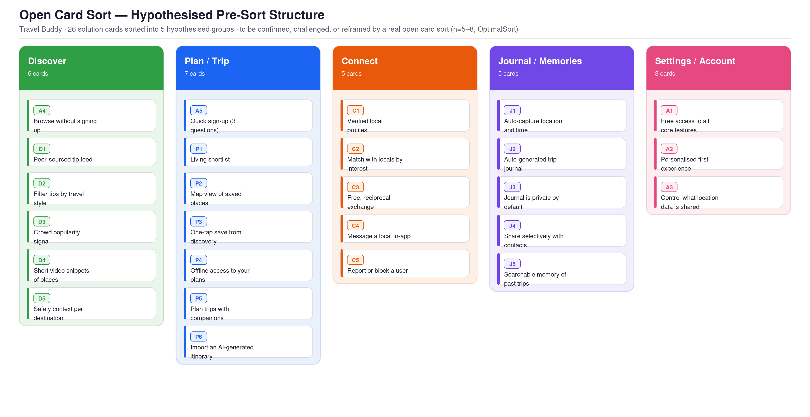
Figure 1. Open card sort — hypothesised pre-sort structure (26 cards across 5 groups). Designed but not yet run with participants.
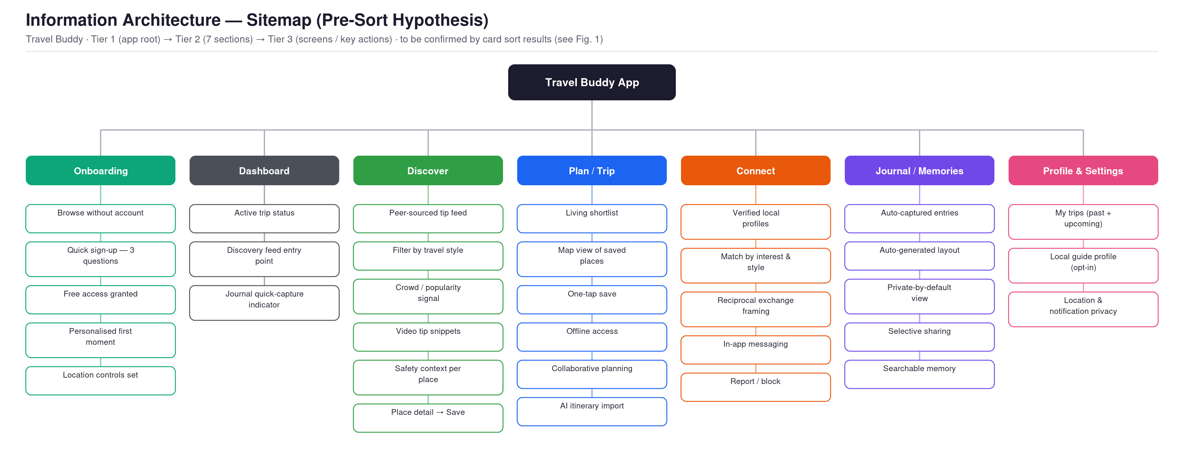
Figure 2. Information architecture sitemap, Tier 1 (app root) to Tier 3 (screens/actions) — pre-sort hypothesis, pending card-sort validation.

7.2 User flow
A user flow is a visual representation of the path a user takes when interacting with a product, from entry points to task completion (Dippner, 2022, p. 168). The user’s flow captures what the user does, how they make decisions, and which states are included. For Travel Buddy, this maps directly to the four phases of the travel experience as Onboarding, Pre-Trip, In-Destination, and Post-Trip, plus a loop phase that returns the user to the start.

The user’s flow only includes the happy path, which defines the core product promise. Edge cases and error states are addressed in subsequent interaction design phases.
Image 2: Travel Buddy user flow.

8. Prototype
Based on the user’s insights and solutions pool defined in the last step, the hi-fi prototype is developed with close attention to the look and feel to represent how users interact with the product. It is a complete visual language that includes color, typography, and design elements alongside real content and interactive components. The goal is to translate the idea to a tangible interface that users can interact with; this sets the stage for user feedback and team conversation, leading to related decisions.

The prototype demonstrates the following areas such as onboard new user, explore locations and connect with local, plan for the trip and share for collaboration, document journal and share
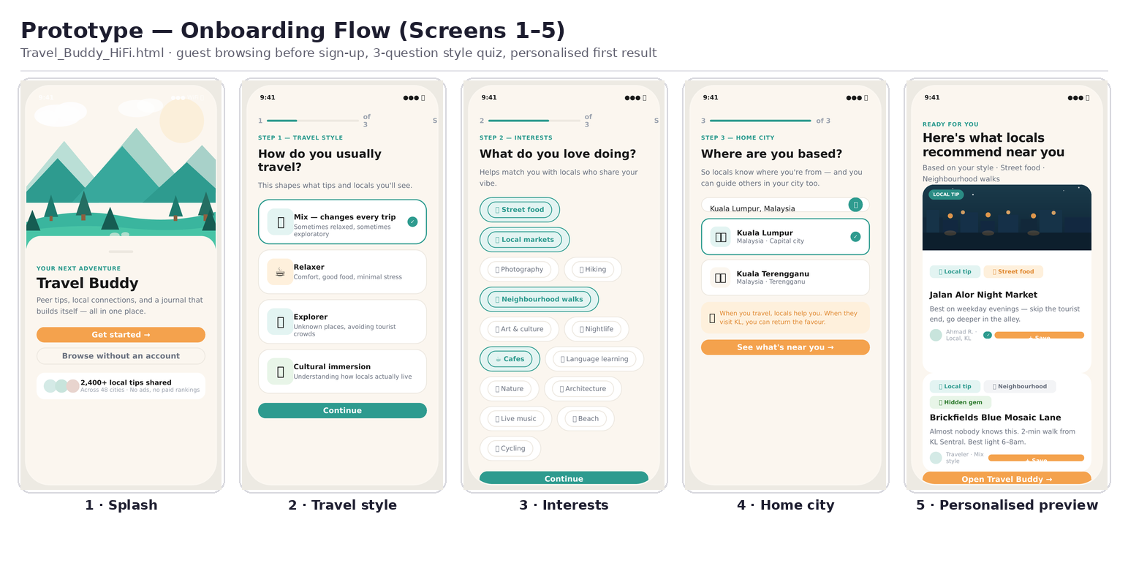
Figure 3. Onboarding flow, screens 1-5 (Travel_Buddy_HiFi.html) — guest browsing before sign-up, 3-question style quiz, personalised first result.
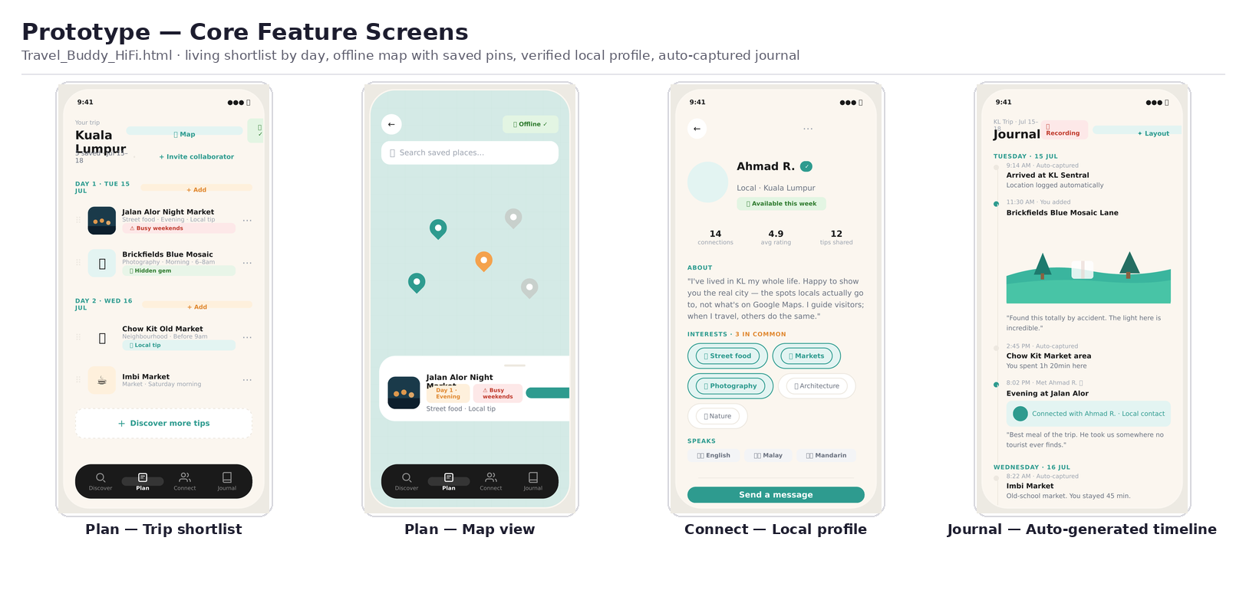
Figure 4. Core feature screens — living trip shortlist by day, offline map with saved pins, verified local profile, and the auto-generated journal timeline.

Image 3: The prototype link can be found here

9. Validation
To validate the decisions, three participants underwent moderated usability testing, in which they were given tasks, walked through the prototype while thinking aloud, and then gave feedback. Moderated testing was chosen because it was precisely guided by the presence of a live observer who could capture not just what a participant does but also why, including the reasoning, hesitation, and in-the-moment reactions behind any click (Dippner, 2022). Participants were screened for young travelers who take at least twice per year and enjoy exploring new places and connecting with new people.

What went well
Participants want the app’s features. Saving tips to specific days improves planning, and personalized messages help connect with locals.

What needs to improve
Insight | Theme | Severity
Participants struggled to find local profiles due to missing search and filters. | Local browse | Critical
Journal has no search, no invite by name/email, and no way to add anyone not already on the list, so people outside the app cannot be selected. | Journal | Critical
Tip attribution reads "Local resident" while the journey framing refers to "another traveler," momentarily unclear whether it satisfies the ask. | Discovery feed | Major
The trip card shows an aggregate save count immediately after a single save, without confirming which trip plan the item was added to, a risk when a user has multiple trips in progress. | Add to plan | Major
Table 11: Testing insights

Recommendations
- Build a single reusable “find or invite a person’ feature to provide a better browsing experience for locals.
- Provide a local profile with their own tips for engaging the community and enhancing social experience.
- In the Journal's share flow, surface the existing view-only link more clearly as a way to share privately with anyone not already on the fixed contact list, and add name/email invite as a further improvement.
- Broaden the UI's source label (e.g., "Resident · Contributor" or a shared "Community tip" framing) so that traveler- and local-authored tips read as equally valid, regardless of how future task copy is worded.
- While exploring and saving a tip, allow the user to choose which trip plan they want to add it to.

10. Portfolio & Strategic Reflection

10.1 UX Strategy Summary
Travel Buddy solves three compounding problems: fragmented planning, commercial bias in discovery, and connection that is only available transactionally. Travel strategy is summarized as the business strategy, value innovation, validated research, and frictionless UX (Dippner, 2022)

Pillar | How Travel Buddy applies it
Business strategy | Differentiation, not price but bring the connection between traveler with location they visit
Value innovation | It proves connection value, delivered free and frictionless
Validated research | Each core research tested with the real people before a screen was built
Frictionless UX | All in one product, zero effort to capture the journal
Table 12: UX Strategy Summary

10.2 Value Logic
User value: One connected flow instead of multiple apps, genuine local connection without worrying about paywall friction, zero effort to capture the memory and sharing capability for private sharing.

Business value: free core product, monetized via optional physical outputs such as Polarsteps' print-book model generates 100% of its revenue this way (Peecho, 2022) plus a premium tier for collaborative planning. Compounding advantages: network effects (every Local Match and shared journal brings in new users) and a data moat (anonymized travel data improves recommendations without paid placements, avoiding TripAdvisor's trust problem).
The strategy monetizes by building trust, not extracting it from it.

10.3 Critical Reflection
The honest state of outcome measurement is missing; there is no clear idea of what the outcome looks like,e and less confidence even if the solution has been tested. In the usability testing, metrics such as SUS, task completion rate, and related metrics were not captured during the session. The project included a lot of solutions and functionality, so it is difficult to tell what is most valuable in the application because it tells a lot of stories under one application.

If this project were repeated, the sequencing would change materially: stress-test which solutions or functionality the user wants most rather than cover all of them. Building screens ahead of structural validation risks anchoring the design on an IA that only feels tested.

References
Ahmad, W., & Sun, J. (2018). Modeling consumer distrust of online hotel reviews. International Journal of Hospitality Management, 71, 77–90. https://doi.org/10.1016/j.ijhm.2017.12.005
Birenboim, A., Bulis, Y., & Omer, I. (2023). A typology of tourism mobility apps. Tourism Management Perspectives, 48, Article 101161. https://doi.org/10.1016/j.tmp.2023.101161
Dippner, D. (2022). User Experience Design – Principles & Methods. SRH Fernhochschule.
Enterprise Nation. (2024). Using SWOT Analysis to Research Competitors and Customers. https://www.enterprisenation.com/learn-something/using-swot-analysis-research-competitors-customers/
Gilbert-Jones, R. (2024, November 5). How authentic experiences shape the new tourism economy. Skift Research. https://research.skift.com/reports/how-authentic-experiences-shape-the-new-tourism-economy/
Gladkiy, S. (2016). UI/UX Terminology: What Every Designer Should Know. https://djan-gostars.com/blog/ui-ux-terms-everyone-should-know/
Kimola. (2024). Unlock Travel App Success: Polarsteps Feedback Analysis. https://kimola.com/reports/unlock-travel-app-success-polarsteps-feedback-analysis-google-play-en-141063
Latterly.org. (2024). Airbnb SWOT Analysis: Competitive Outlook for Hosts and Guests. https://www.latterly.org/airbnb-swot-analysis/
Meegle. (2024). Competitor SWOT Analysis. https://www.meegle.com/en_us/topics/market-intelligence/competitor-swot-analysis
Peecho. (2022). Peecho print API helps Polarsteps monetize user content with print on demand travel books [Case study]. https://www.peecho.com/case-studies/polarsteps
SalesMotion. (2024). Competitive Analysis SWOT. https://salesmotion.io/blog/competitive-analysis-swot
Spies, M. (2014). Branded Interactions. Digitale Markenerlebnisse planen & gestalten (Zweite Auflage).
Startuprad.io. (2024). Polarsteps Growth: Privacy-First Travel App at 18M Users. https://www.startuprad.io/post/polarsteps-growth-privacy-first-travel-app-at-18m-users-startuprad-io
The Strategy Story. (2024). TripAdvisor SWOT Analysis. https://thestrategystory.com/blog/tripadvisor-swot-analysis/
Streetwise Journal. (2024). Airbnb SWOT Analysis: Risks, Opportunities & Insights for 2024. https://streetwisejournal.com/airbnb-swot-analysis/
What Is A User Flow? Data Defined - Indicative. https://www.indicative.com/resource/user-flow/

Appendix
Prototype for Travel Buddy. https://claude.ai/code/artifact/9da37cb9-5304-4598-9ed6-ba9a35b9aa2f
Table 1: Double diamond process
Table 2: Personas
Table 3. Condensed SWOT of selected competitors
Table 4: Travel Buddy SWOT
Table 5: Solution for discovery
Table 6: Solution for connect
Table 7: Solution for travel planning
Table 8: Solution for collaborative
Table 9: Solution for journal and memory
Table 10: Card sorting
Table 11: Testing insights
Table 12: UX Strategy Summary

